**Add a User via the Portal. Steps below**:

* Log in as Super admin
* From the portal, click on **Directory**and then **People**
* Click **Add Person**

**Populate the following fields for user. Steps blow:**

* **First name**, **Last Name**, **Username**, **Primary email.**
* Activation**: Active now**, Check **Activate now,** Enter password **,** Uncheck **User must change password on first login**
* Click **save**

Confirm that the new user is listed on the **People**page

Assure user can log in.

**Add custom attribute. Steps below:**

* Click **Directory, Profile Editor,** then **okta user**

* Click **Add Attribute,** Display Name **Preferred Name,** Variable name **preferredName,** check **Read-Write,** click **Save**

Make sure custom attribute is added.

**Add preferred name.**

* Click **Directory**, click **People**, then username **Tom Ford**

* Click **Profile**, click **Edit**, Preferred Name **Tom,** then click **Save**

**Import users into Okta, using a CSV file. Steps below:**

* From the super admin portal
* Click **Directory,** click **People,** click **More actions,** then **Import users from csv**

* Download the CSV template

* Populate the following fields for user: **login**, **firstname**, **lastname**, **email**, **department**.

* Click **Browse,** then open cvs file, click **Upload CSV**
* Confirm successful validation and then click **Next**

* Check **Automatically activate new users,** Click **Import Users**

* Click **Done**

Confirm that the new users are listed on the **People**page

Remember to login as users to activate users accounts.

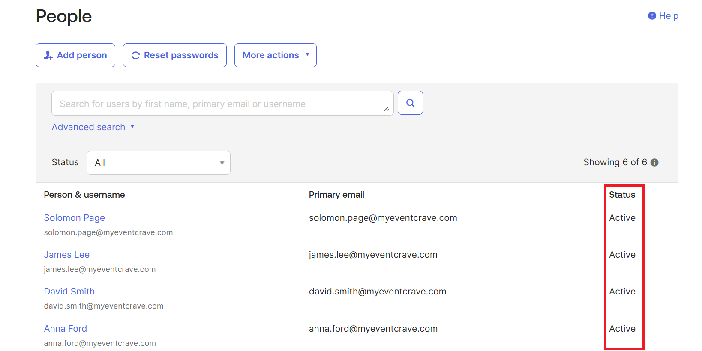

**Create a group, Add users to group by rule, And also add users to group manually. Steps blow:**

* From the portal, click on **Directory,** Click on **Groups** and then **Add group**

* Populate **Name, Group Description,** then click **Save**

* click on **Rules,** then click **Add Rule**

* Name: **Marketing Rule**, Select User attribute, select **department | string,** populate **Marketing,** Assign to **All Contractors,** Click on **save**

* Click **Action**, then click **Activate**

* Confirm users are added to **Marketing** group by rule

* From the portal, click on **Directory,** Click on **Groups** and then **Add group**

* Populate **Name, Group Description,** then click **Save**

* Confirm group is created

**Assign users to group manually.**

* From the portal, click on **Directory,** Click on **Groups** and then **Sales**

* Click **People**, click **Assign people,** then assign users

Confirm users were assign to group manually.

